BUXTON / MICROSOFT COLLECTION
home | explore | associated narratives | about | acknowledgments | contact

Gavilan Computer Corp. Gavilan SC
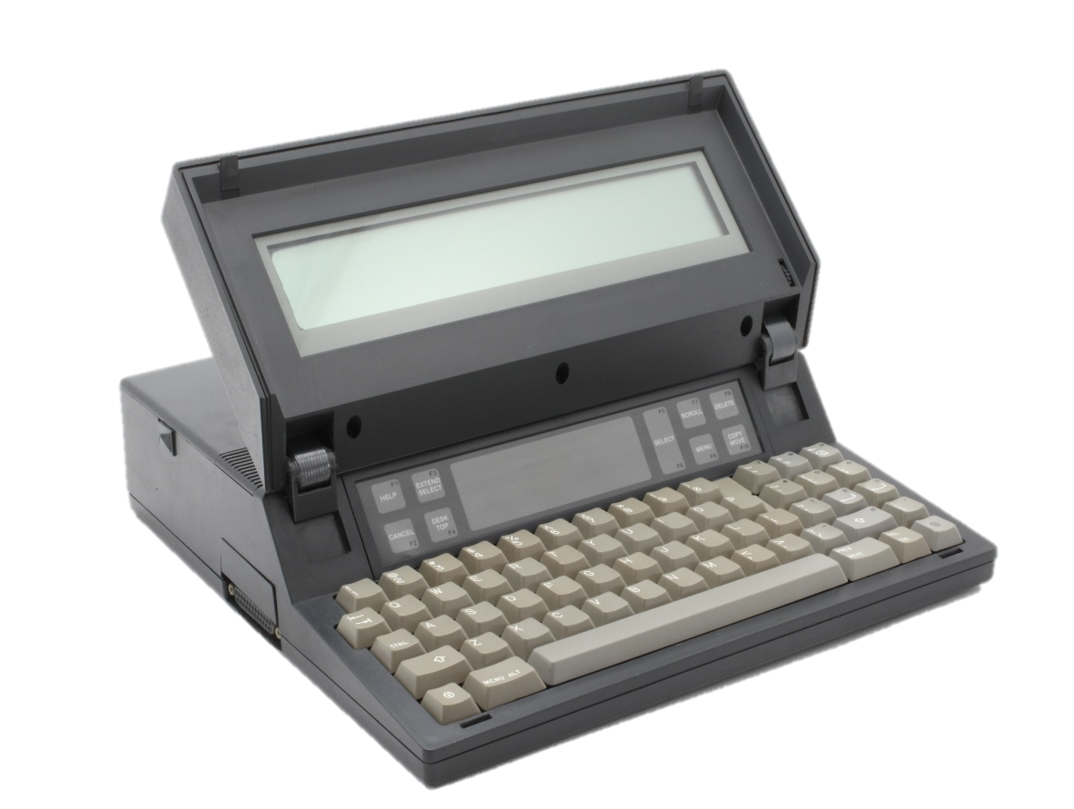
Short Description: This is the first battery-powered clam-shell laptop. It is also the first laptop to incorporate a pointing device – in this case a touch pad, which can be seen mounted above the keyboard. The LCD was text only, and could only display 8 lines of text, 24 characters each – which was actually pretty good at the time.

Bill Buxton’s Notes
To come
Notes:
- Introduced May 1983
- Internal 3.5” floppy (missing on my unit).
- ID by Jack Hall and Hall Design in combination with C. Itoh of Japan.
- Weight 4 kg (9 lb) including battery and floppy. (compare to 10 lbs, 4 oz, GRiD Compass with and without floppy)

Device Details
Gavilan Computer Corp. | Year: 1983 (1984) | Original Price (USD): $3,995.00
Degrees of Freedom: 2
Dimensions (L x W x H): XXX x XXX x XXX (mm) Note: watch is W x D
Key Words
Primary: Laptop Computer
Secondary: Touchpad
Links
- Detailed photographs with summary of key dates, technical information and company/product history: http://www.oldcomputers.net/gavilan.html (Local copy: Gavilan_Old_Computers.PDF)
- John C. Dvorak: What Ever Happened to the Gavilan SC: http://www.dvorak.org/blog/whatever-happened-to-the-gavilan-mobile-computer/ (Local copy: Gavilan_Dvorak_Whatever.PDF)
- Wikipedia Page: https://en.wikipedia.org/wiki/Gavilan_SC (Local copy: Gavilan_Wikipedia.PDF)
- Phil Lemmons, The Gavilan Mobile Computer, review, Byte, June 1983, Vol. 8(6), 74,-92 (even pages only): http://archive.org/stream/byte-magazine-1983-06/1983_06_BYTE_08-06_16-Bit_Designs#page/n75/mode/2up (Local copy: Gavilan_Byte.PDF)

Image | File Name | Caption
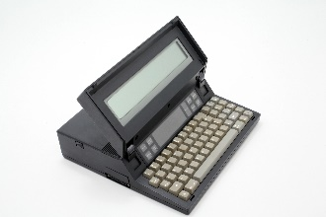 | Gavilan_IMG_7835.JPG | Open Gavilan SC High 3/4 Front View
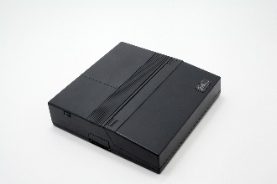 | Gavilan_IMG_7839.JPG | Closed Gavilan SC High 3/4 Front View
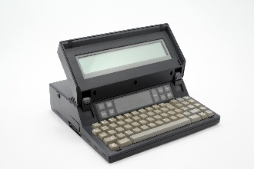 | Gavilan_IMG_7847.JPG | Open Gavilan SC Mid 3/4 Front View
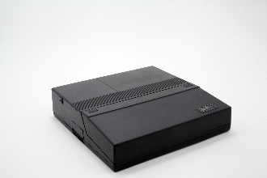 | Gavilan_IMG_7851.JPG | Closed Gavilan SC Mid 3/4 Front View
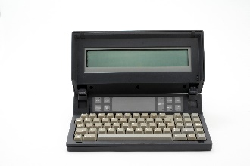 | Gavilan_IMG_7859.JPG | Open Gavilan SC Full Front View
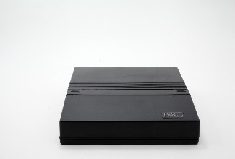 | Gavilan_IMG_7864.JPG | Closed Gavilan SC Mid Front View
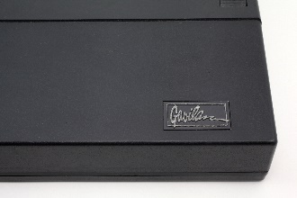 | Gavilan_IMG_7880.JPG | Closed Gavilan SC Close Front Right View
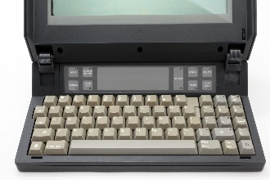 | Gavilan_IMG_7884.JPG | Open Gavilan SC Keyboard and Touch Pad View
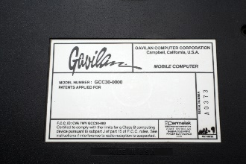 | Gavilan_IMG_7911.JPG | Gavilan SC Bottom Identification Plate
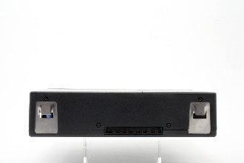 | Gavilan_IMG_7922.JPG | Closed Gavilan SC Straight-On Back View
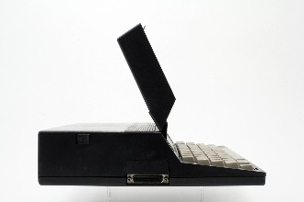 | Gavilan_IMG_7934.JPG | Open Gavilan SC Left Side View
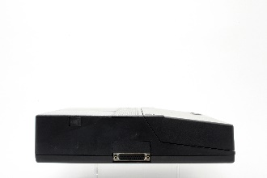 | Gavilan_IMG_7942.JPG | Closed Gavilan SC Left Side View
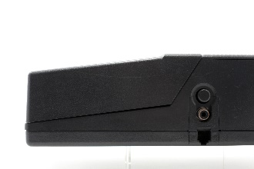 | Gavilan_IMG_7953.JPG | Closed Gavilan SC Partial Right Side View
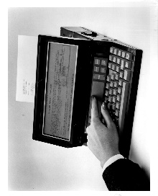 | Gavilan_01.jpg | The Gavilan mobile computer is a complete office automation system designed for business professionals who are new to computers. The integrated touch panel, or solid state mouse, shown in this photo enables the user to easily control the cursor for menu item selection and on-screen data manipulation.  The Gavilan mobile computing system includes a 16-line by 80 character LCD display, a touch panel, a 3 ½” floppy disk drive, 64 Kbytes of RAM, and a full typewriter-like keyboard and 10-key numeric pad.  Standard software includes Gavilan’s fully integrated proprietary software know as CasuleWare, industry standard MS-DOS operating system, and MS-BASIC, Pascal and C programming languages. Bundled CapsuleWare applications include CapsuleWord, CapsuleCalc and CapsuleComm.  Photo Credit: Gavilan Computer Corporation
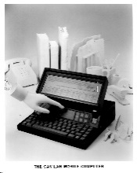 | Gavilan_02.jpg | The Gavilan Mobile Computer.  Photo Credit: Gavilan Computer Corporation
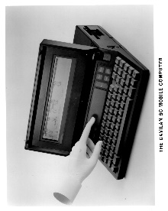 | Gavilan_03.jpg | The Gavilan SC Mobile Computer.  Photo Credit: Gavilan Computer Corporation
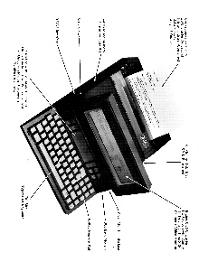 | Gavilan_04.jpg | The Gavilan SC Mobile Computer with parts labelled.  Photo Credit: Gavilan Computer Corporation
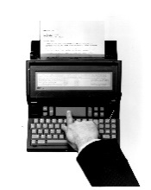 | Gavilan_05.jpg | Gavilan’s integrated touch panel acts like a “solid state mouse” that enables the user to move a pointer on the screen to the file or item desired. The user then “taps” the screen to make a selection. This visual orientation – the ability to maneuver objects on the screen – gives the first-time user the ability to learn quickly and receive help from the machine as needed.  Gavilan’s software experts developed the “human interface software” for this mobile computer function. A new owner can typically learn to operate the machine in about 30 minutes.  Photo Credit: Gavilan Computer Corporation
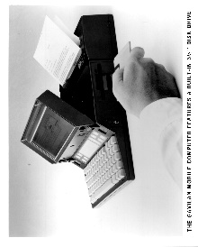 | Gavilan_06.jpg | The Gavilan Mobile Computer features a built-in 3 ½” disk drive.  Photo Credit: Gavilan Computer Corporation
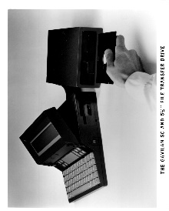 | Gavilan_07.jpg | The Gavilan SC and 5 ¼” file transfer drive.  Photo Credit: Gavilan Computer Corporation
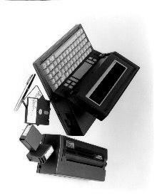 | Gavilan_08.jpg | The Gavilan is a truly mobile computer designed to meet the needs of business and professional people who travel. It is battery powered and fits inside a standard briefcase.  The 11 X 11 X 2 inch main unit weighs nine pounds and includes a 16-bit 8088 microprocessor, an 8 line X 66 character LCD flat panel display, an integrated solid state “mouse” for user interface, a full-size typewriter style keyboard and 10 key pad, and three inch disk drive.  The optional printer is full sheet correspondence quality with a sheet paper feeder and weighs five pounds. It prints at a speed of 50 characters per second, and also fits into a briefcase along with the main Gavilan unit.  Gavilan applications software is available on plug-in “capsules: and includes word processing, spreadsheet, portable secretary, communications and mail, and forms control.  Photo Credit: Gavilan Computer Corporation
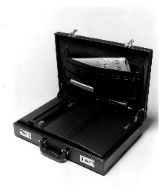 | Gavilan_09.jpg | The Gavilan is completely portable, fits into a standard size briefcase, and is ready to run for up to eight hours on its rechargeable battery pack. The correspondence quality printer has a separate battery pack. It is detachable, and can be left behind if not needed.  Photo Credit: Gavilan Computer Corporation
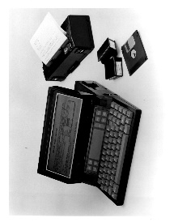 | Gavilan_10.jpg | The Gavilan mobile computer is a complete traveling office automation system designed with the needs of the business professional in mind.  The Gavilan computer includes a 16-line by 80 character LCD display, an integrated touch panel, or solid state mouse, for easy cursor control, and integrated 3 ½ “ floppy disk drive, 64 Kbytes of RAM, and a full typewriter style keyboard with 10-key numeric pad.  Gavilan software, including CapsuleWord, CapsuleCalc and CapsuleComm, is fully integrated and offers the user complete date manipulation capabilities. CapsuleWare application programs come on either 3 ½” diskette or on ROM capsules.  The Gavilan mobile printer is a thermal ribbon, dot matrix printer which operates off its own internal batteries, and produces correspondence quality documents.  Photo Credit: Gavilan Computer Corporation
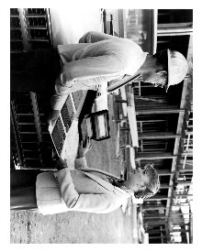 | Gavilan_11.jpg | Gavilan computer Corporation’s family of mobile computing systems has been expanded with the introduction of the Gavilan SC, and MS-DOS version of the Gavilan mobile computer.  Featuring many of the same features as the Gavilan, including an integrated touch panel, or solid-state mouse, a 3 ½” floppy disk drive, 64 Kbytes of RAM, and a full typewriter style keyboard and 10-key numeric pad, the Gavilan SE is designed to meet the needs of mobile professional who may not require the sophisticated capabilities of Gavilan’s fully integrated software.  The Gavilan SC includes the industry standard MS-DOS operating system which runs may industry standard application packages now offered through Gavilan. The Gavilan SC comes with the 8-line by 80 character LCD display.  Photo Credit: Gavilan Computer Corporation
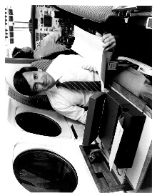 | Gavilan_12.jpg | Manny Fernandez, president of Gavilan Computer Corporation, demonstrates the mobility of the Gavilan. The battery-powered, nine point, 16-bit microcomputer system and its proprietary software were designed specifically for the mobile executive who needs an office in a briefcase. Photo Credit: Gavilan Computer Corporation
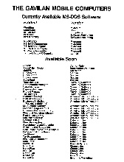 | Gavilan_Available_SW.jpg | List of Software Available for Gavilan Mobile Computers
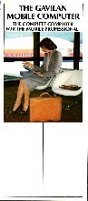 | Gavilan_Mobile_Brochure.jpg | Sales Brochure for the Gavilan Mobile Computer  Gavilan_Mobile_Brochure.pdf
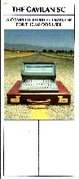 | Gavilan_SC_Brochure.jpg | Sales Brochure for the Gavilan SC Mobile Computer Gavilan_SC_Brochure.pdf
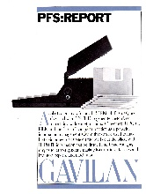 | Gavilan_PFS_Report.jpg | A brochure promoting the ability of the Gavilan to run an application, PFS:Report, which was designed to generate reports in tabular form.
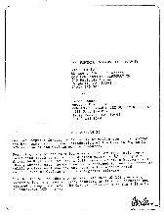 | Gavilan SC annoncement.jpg | A letter announcing the addition of the SC version of the Gavilan, which ran MS-DOS.

