BUXTON / MICROSOFT COLLECTION
home | explore | associated narratives | about | acknowledgments | contact

Amazon Kindle Keyboard Lighted Leather Cover, Apple Green
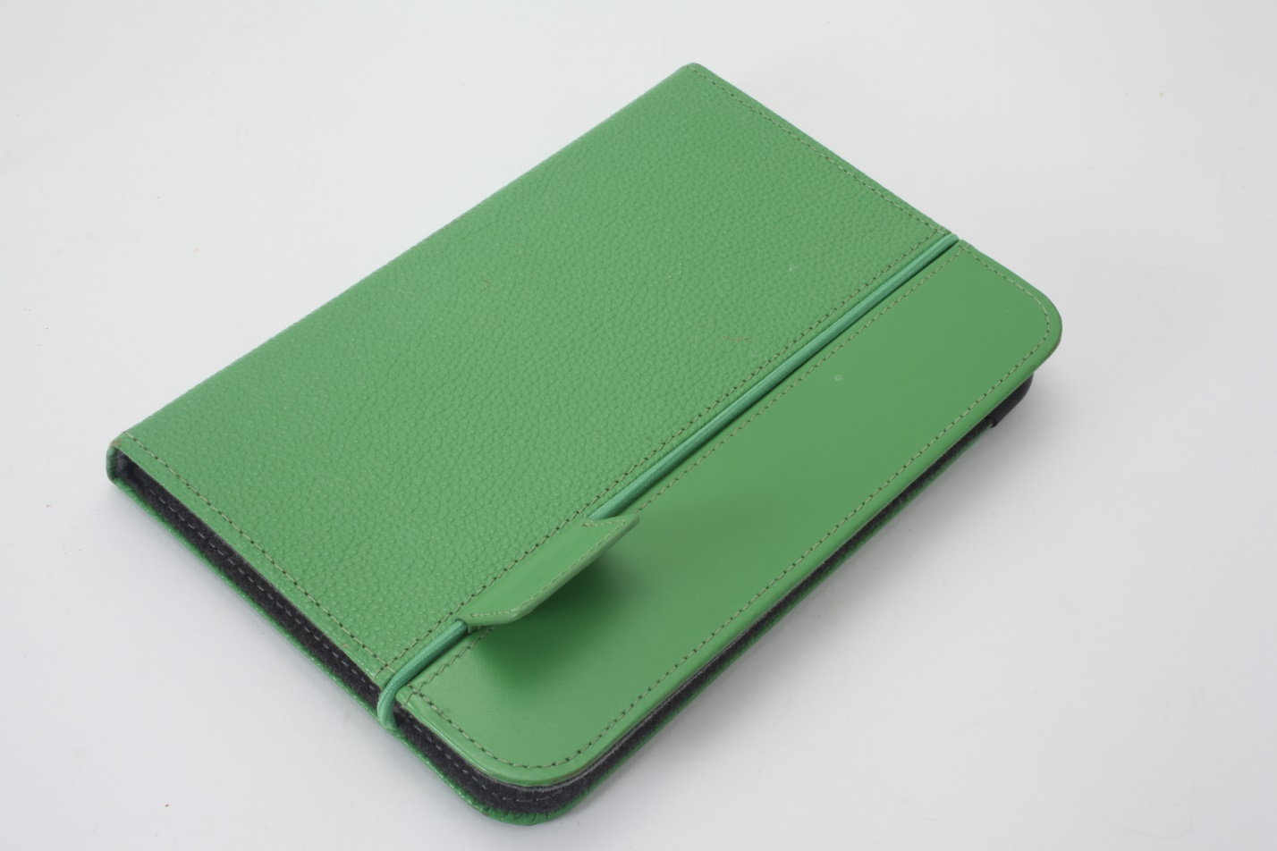
Short Description: This is a leather “book-jacket” for the Amazon Kindle Keyboard e-reader – the third generation Kindle offered. Besides providing protection to the device, and giving it a far more organic feel, it has a built-in reading light which enables the e-ink reflective display to be read in a dark space.

Bill Buxton’s Notes
The Amazon Kindle e-reader uses reflective e-ink display technology. That is, it behaves much like electronic paper: in light you can see what is displayed on the screen, but unlike a laptop, in the dark, you cannot. While this significantly increases battery life, it means that you cannot read in bed unless you have suitable task lighting - lighting which may not be available. What this cover introduced was a built-in retractable reading light. Located in the top right corner of its back, the light is normally hidden. When pulled out, the extended light turns on automatically, and is powered by the Kindle’s battery.
Released August 27th, 2010, the cover is made of pebble-surfaced leather, and is available in 7 colours:
- Burnt Orange
- Hot Pink
- Chocolate Brown
- Burgundy Red
- Apple Green
- Steel Blue
- Black
Besides softening the feel of an otherwise hard plastic gadget, making it feel far more book-like, and providing an always available reading light, it also does an excellent job of protecting the Kindle.

Device Details
Company: Amazon | Year: 2010 | Original Price (USD): $59.99
Design: XXX
Degrees of Freedom: NA
Dimensions (L x W x H): 197 x 130 x 9.5 (mm) (Closed)
Key Words
Primary: e-reader Cover
Secondary: Light
Links
- Review: https://obviate.io/2010/09/01/review-kindle-lighted-leather-cover/
- Amazon Product Page, August 2nd, 2010: https://web.archive.org/web/20100802090108/http://www.amazon.com/Kindle-Lighted-Leather-Display-Generation/dp/B003DZ167K

- pdf file

- powerpoint

- Vimeo video link

- XXX

Image | File Name | Caption
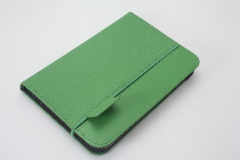 | Kindle3_Cover_01_ Front.JPG | Closed apple green lighted leather cover for the Amazon Kindle Keyboard.
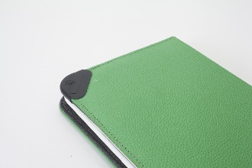 | Kindle3_Cover_02_Light_Retracted.JPG | Detail of the back of the closed lighted cover for the Amazon Kindle Keyboard showing location of the retracted integrated light.
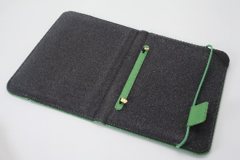 | Kindle3_Cover_03_Light_Retracted.JPG | The open lighted keyboard cover, without the Amazon Kindle, with the integrated light retracted.
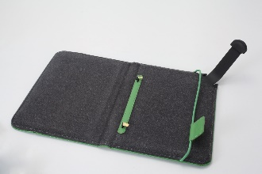 | Kindle3_Cover_04_Light_Extended.JPG | The open lighted keyboard cover, without the Amazon Kindle, with the integrated light extended.
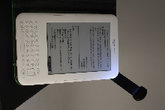 | Kindle3_Cover_05_Light_on.JPG | Detail of the Amazon Kindle Keyboard e-reader, in the dark, with the cover’s integrated reading light illuminating its display.
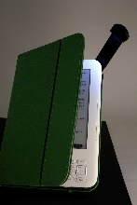 | Kindle3_Cover_06_Light_on.jpg | A different view of the Amazon Kindle Keyboard e-reader, in the dark, with the cover’s integrated reading light illuminating its display.
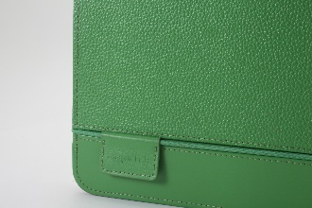 | Kindle3_Cover_07_Detail.JPG | A detail of the cover highlighting the pebble-grain of the leather.
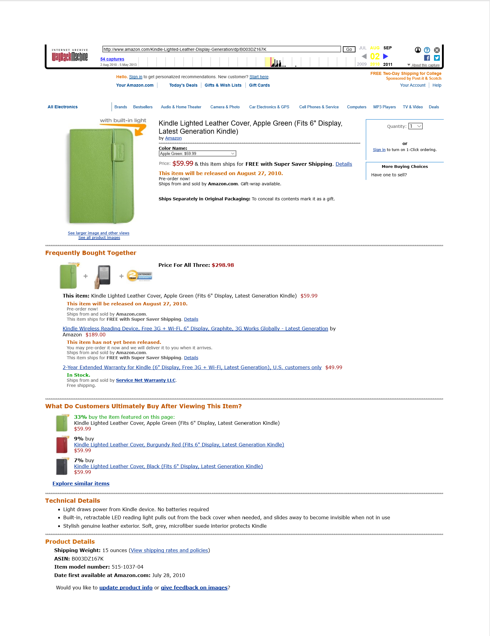 | Kindle_Lighted_Cover_Product_Page.JPG | Original 2010 Amazon.com product description page for the Kindle Lighted Leather Cover. Click on image to access document.

WORK NOTES:

