BUXTON / MICROSOFT COLLECTION
home | explore | associated narratives | about | acknowledgments | contact

NewO Writehander
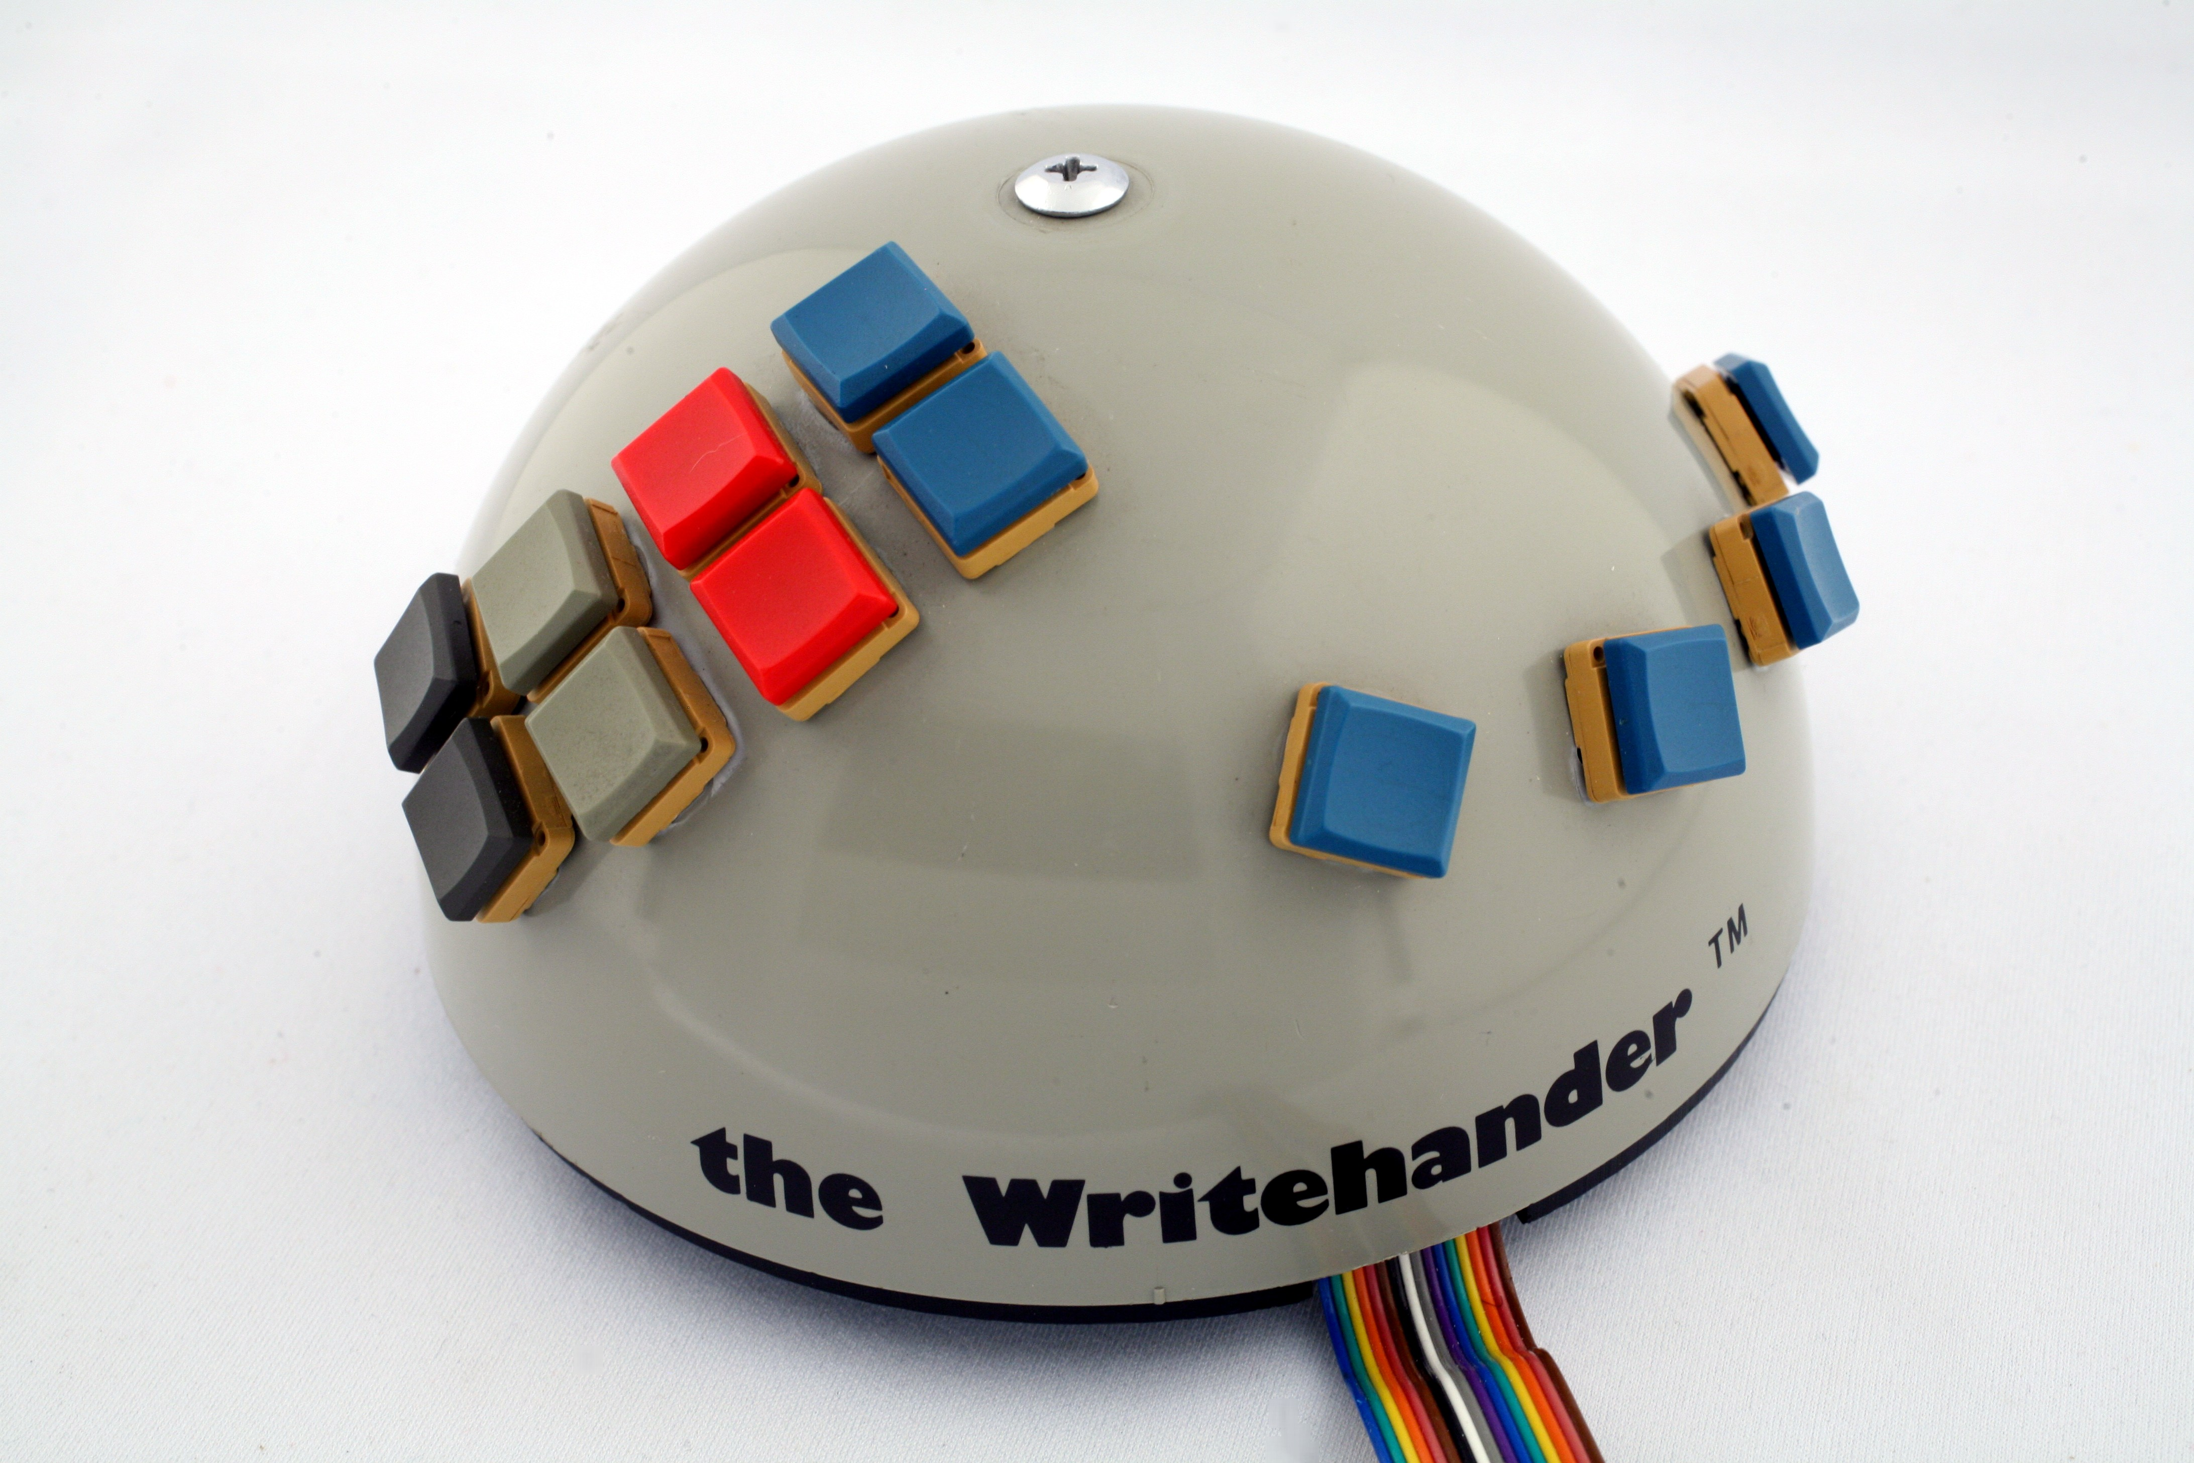
Short Description: The Writehander is a twelve-button, one-hand chord keyboard. The one pictured here is the left-hand version. The four fingers sit on the four blue buttons in a row. The thumb pushes one of the other eight coloured buttons. The chords are the eight-bit ASCII code for the desired character, with the fingers defining the four low-order bits and the single thumb key pressed defining the four high-order bits..

Bill Buxton’s Notes
The Writehander is a chording keyboard released in 1978 that enabled one to enter text with only one hand. It came in both a right and left-handed version. I have one of each, but this one is the one designed for entering text with the left hand.
One might tend to assume that the left-hand version of the Writehander is intended for left-handed people. Generally, that is true if one is only typing. Yet, if a right-handed person is using a mouse and Writehander together, it is most likely that the mouse would be used in the preferred right hand, and the Writehander in the left. Furthermore, with chord keyboards capable of entering the full character set using one hand, it is generally the case that the highest typing speed is attained by assigning a separate keyboard for each hand, and alternating which keyboard is used to enter each successive character. To understand this, test how fast you can tap on a table-top with your index finger. Next, do the same thing, but alternated between the index fingers of one hand and then of the other..
The hemispheric form was designed to comfortably accommodate the hand laying over top of it with the four fingers resting on top of the horizontally-oriented curved row of four blue buttons, and the thumb in a position where it can activate any one of the vertically-oriented row of four pairs of coloured buttons (from top-to-bottom, blue, red, grey and black, respectively).
Which character is entered is determined by the combination of the four blue finger buttons are depressed when one of the eight coloured thumb buttons is pushed. That is, pushing the finger buttons has no effect until a thumb button is pushed. Therefore, unlike playing a piano chord in music, the novice need not (but may) push all buttons in the chord simultaneously – as long as the thumb is the last one pushed. Of course, high entry speeds depend on simultaneous, or near simultaneous chord entry.
The total number of distinct characters that can be entered equals the number of thumb-buttons (8) times the number of combinations of the four finger buttons (16). This comes to 128, which is enough to represent the full character set used in basic typing.
The finger/thumb chord combinations used for the left- and right-hand versions of the keyboard are mirror-images of each other, which will facilitate transferring skill acquired using one hand device to the other.
At the conceptual level, the chord combinations are based on what is known as “7-bit ASCII coding”, which is an international standard for digitally representing characters in computers. The four finger buttons correspond to the four least-significant bits in the 7-bit coding (the buttons for index finger - little finger correspond to b₁ – b_{4,} respectively). The remaining three high-order bits are determined by which of the 8 thumb buttons is pushed. The precise mapping for both the left- and right-hand versions of the device are shown in the accompanying Finger Code Charts. A full user-manual is also included.
Finally, while ASCII coding has been effective for computers, and has been used by other chord keyboards, its adoption is more likely in order to make things simpler technologically than for the human user. Hence, one of the things to consider with chord keyboards is the choice of coding scheme involved. The reason is that, unlike most keyboards, to enter text on a chord keyboard one must be able to touch-type. Hence, learnability of the codes is a significant barrier to entry.
The reason stems from the fact that any particular key may be included in the code for several different character codes. Hence, labelling the key-caps in any useful way is difficult, if not impossible. Thus, you cannot hunt-and-peck your way around the keyboard the way you can on regular ones. Hence, the easier the finger coding is to learn, the easier that transition is for the user. In order to emphasize that there are other codings, and ways to teach them, the reader is highly encouraged to compare the Writehander, with its coding and documentation, with another chord keyboard, the Microwriter, which is also in the collection.

Device Details
Company: NewO Company | Year: 1978 | Original Price (USD): $120.00
Degrees of Freedom: NA
Dimensions (L x W x H): 126 x 80 (mm)
Key Words
Primary: Chord Keyboard
Secondary: Keyboard, One-Handed Keyboard

Links
- NewO User Manual

Image | File Name | Caption
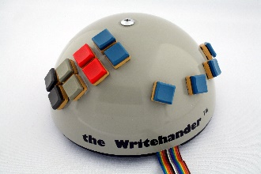 | NewO_1_Front.JPG | The left-hand version of the NewO Writehander
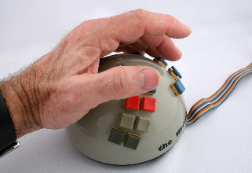 | NewO_2_Hand.JPG | The left-hand Writehander showing how the hand is positioned during operation (see text).
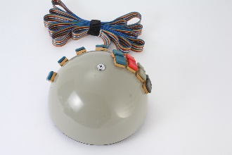 | NewO_3_Back.JPG | Upper view of back of left-hand Writehander.
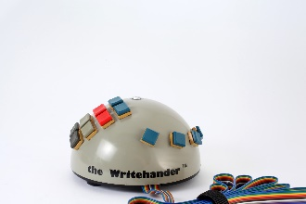 | NewO_4_Side.JPG | Side view of Writehander showing blue buttons for the 4 fingers and the 8 coloured thumb buttons
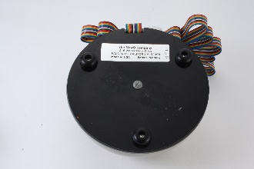 | NewO_Bottom.JPG | Bottom view of the left-hand version of the NewO Writehander
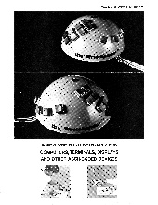 | NewO_Brochure.jpg | Font page of NewO Writehander brochure. Click to open brochure PDF.
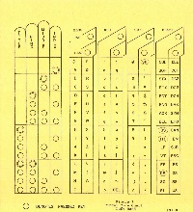 | NewO_Finger_Chart_Left_Hand.jpg | A chart showing the mapping between finger positions on the buttons and character entered for the left-hand Writehander.
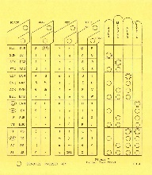 | NewO_Finger_Chart_Right_Hand.jpg | A chart showing the mapping between finger positions on the buttons and character entered for the right-hand Writehander.
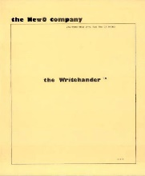 | NewO_User_Manual.JPG | The cover of the Writehander User’s Manual. See the link below to access the pdf containing the full document.
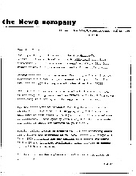 | NewO_Letter.jpg | NewO letter giving customer information such as pricing, options, etc.
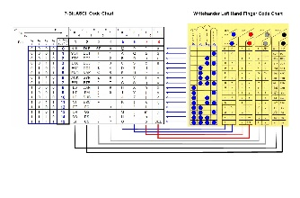 | NewO_Finger_Code_to_ASCII_Mapping.jpg | The finger codes used by the Writehander are based on 7-bit ASCII coding. This image shows illustrates the actual mapping.
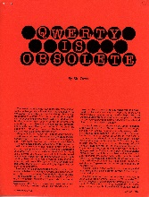 | NewO_QWERTY_is_Obsolete.jpg | Review by Sid Owen from the January 1978 issue of Interface Age announcing that the Writehander makes QWERTY obsolete. (Click on image to open full article.)

